ECA5610- Advance wireless communication systems

Name: S.Gokul
Reg no:192512373

Exp no:3 MATLAB Analysis of Spectrum Bands, Propagation Loss and Cellular Interference

Aim:
To compare a simplified free-space path-loss estimate across representative sub-1 GHz, mid-band and mmWave frequencies, and examine how distance and frequency reuse affect received signal and a simple interference measure.

Objectives:
- Calculate or simulate path loss at representative sub-1 GHz, mid-band and mmWave frequencies.
- Compare estimated received signal strength as frequency and distance change.
- Examine how cell separation or frequency reuse changes a simplified interference ratio.
- Relate the results to coverage and spectrum-use considerations across mobile generations, while stating model limitations.

Requirements:

- Computer with MATLAB R2019b or later.
- No RF hardware is required.

Program :

clear; clc; close all;
% Representative bands and link-budget assumptions
freqGHz = [0.7 3.5 28];
freqMHz = freqGHz * 1000;
bandName = ["Sub-1 GHz"; "Mid-band"; "mmWave"];
txPowerdBm = 30;
gtDbi = 0; grDbi = 0;
distanceKm = logspace(log10(0.1),log10(2),200);
distanceAtPointKm = 0.5;

% Free-space path loss (d in km, f in MHz)
fspl = @(fMHz,dKm) 32.44 + 20*log10(fMHz) + 20*log10(dKm);
lossAtPoint = fspl(freqMHz,distanceAtPointKm);
rxAtPoint = txPowerdBm + gtDbi + grDbi - lossAtPoint;
linkTable = table(bandName,freqGHz(:),lossAtPoint(:),rxAtPoint(:), ...
'VariableNames',{'Band','Frequency_GHz','FSPL_dB','EstimatedRx_dBm'});
disp(linkTable);

% Path loss and received power over distance
figure; tiledlayout(1,2);
nexttile; hold on; grid on;
for k=1:numel(freqMHz)
plot(distanceKm,fspl(freqMHz(k),distanceKm),'LineWidth',1.5);
end
set(gca,'XScale','log'); xlabel('Distance (km)'); ylabel('Path loss (dB)');
legend(bandName,'Location','northwest'); title('Free-Space Path Loss');
nexttile; hold on; grid on;
for k=1:numel(freqMHz)
rx = txPowerdBm + gtDbi + grDbi - fspl(freqMHz(k),distanceKm);
plot(distanceKm,rx,'LineWidth',1.5);
end
set(gca,'XScale','log'); xlabel('Distance (km)'); ylabel('Estimated received power (dBm)');
legend(bandName,'Location','southwest'); title('Illustrative Received Power');

% Simple first-tier co-channel reuse estimate
cellRadiusKm = 0.5;
reuseN = [1 3 7 12];
pathLossExponent = 3.5;
reuseDistance = sqrt(3*reuseN) * cellRadiusKm;
sirLinear = (reuseDistance/cellRadiusKm).^pathLossExponent / 6;
sirDb = 10*log10(sirLinear);
reuseTable = table(reuseN(:),reuseDistance(:),sirDb(:), ...
'VariableNames',{'ReuseClusterN','ApproxInterfererDistance_km','ApproxSIR_dB'});
disp(reuseTable);
figure; plot(reuseN,sirDb,'o-','LineWidth',1.5); grid on;
xlabel('Reuse cluster size N'); ylabel('Approximate SIR (dB)');
title('Simplified Co-Channel SIR versus Reuse Cluster Size');

fprintf('At %.2f km, estimated received powers are:\n',distanceAtPointKm);
disp(table(bandName,rxAtPoint(:),'VariableNames',{'Band','Rx_dBm'}));

Output:

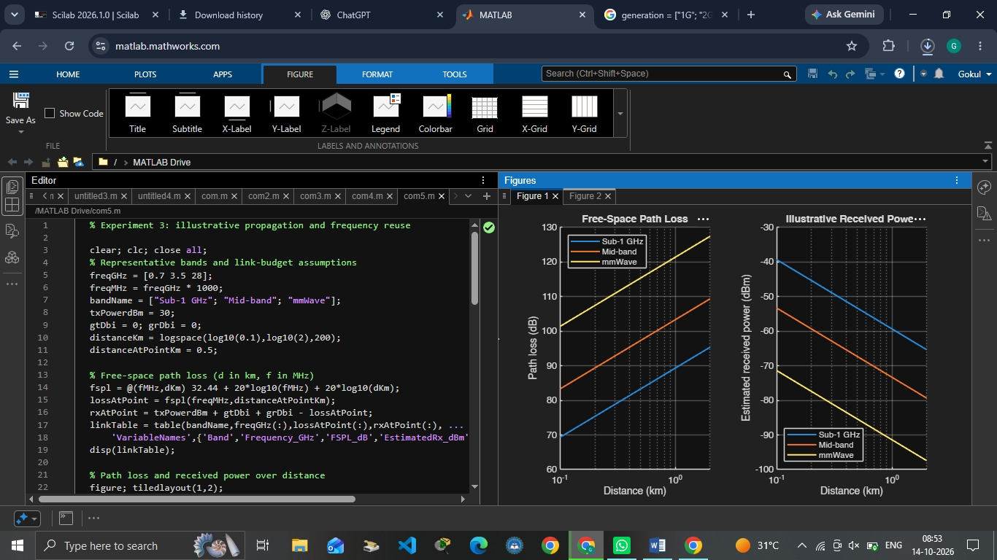

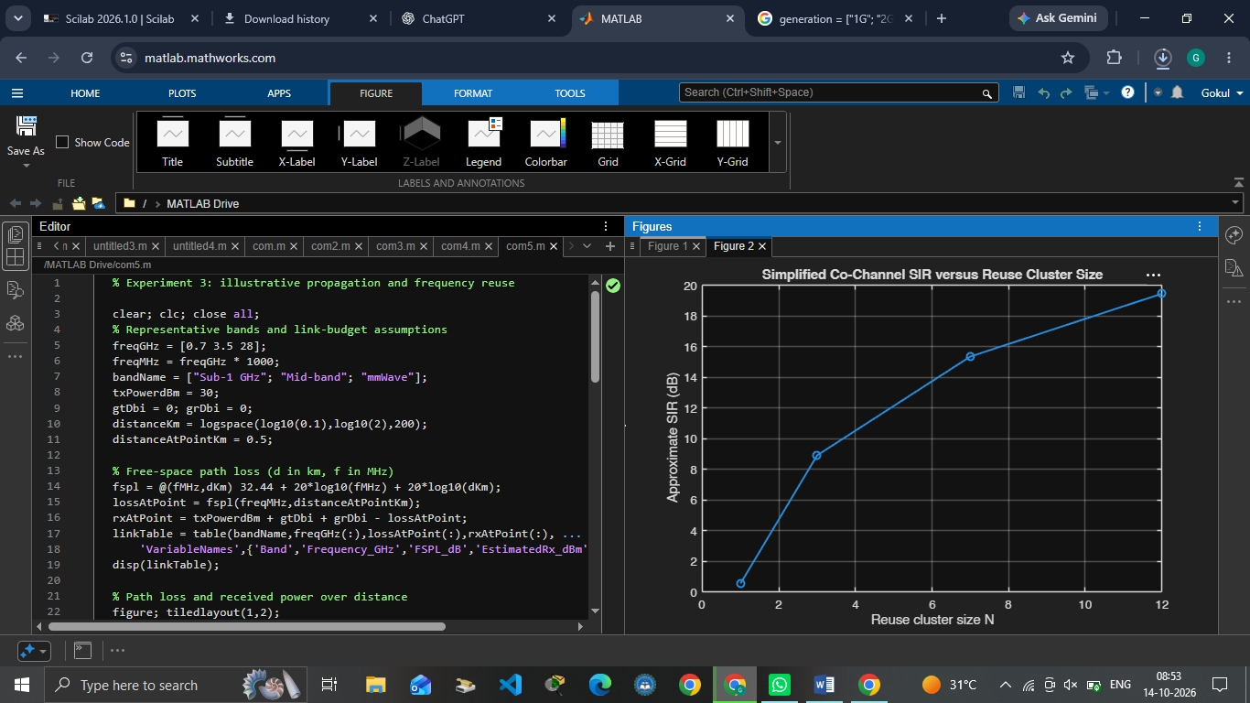

Result:
Higher frequencies (mid-band/mmWave) suffer vastly greater path loss and shorter coverage range than sub-1 GHz bands, requiring denser small-cell layouts. However, increasing cell separation successfully mitigates co-channel interference to optimize network capacity.

